

**MAASAI MARA UNIVERSITY**

**SCHOOL OF SCIENCE AND INFORMATION SCIENCES**

**DEPARTMENT OF COMPUTING AND INFORMATION SCIENCES**

**BACHELOR OF SCIENCE IN COMPUTER SCIENCE**

**COM 4114 COMPUTER SCIENCE PROJECT**

**CRIME REPORTING APPLICATION**

**FINAL REPORT**

**BRIAN NYAGWANGA OMWERI**

**SB06/SR/MN/1714/2016**

**SUPERVISED BY: ESTHER IMBAMBA**

**THIS REPORT IS SUBMITTED TO THE SCHOOL OF SCIENCE AND INFORMATION SCIENCE, MAASAI MARA UNIVERSITY IN PARTIAL FULFILLMENT OF BSc. COMPUTER SCIENCE PROGRAMME.**

# DECLARATION BY THE SUPERVISOR.

This project is my original work and it has not been submitted for the award of any degree in any university or any institution of higher learning.

NAME: BRIAN NYAGWANGA OMWERI

REGISTRATION NUMBER: SB06/SR/MN/1714/2016

SIGNATURE:

**SUPERVISOR’S DECLARATION**.

We append our signatures as our signatures as a confirmation that this has been submitted with our approval as MAASAI MARA UNIVERSITY supervisors.

NAME: Madam Esther Imbamba

DEPARTMENT: COMPUTING AND INFORMATION SCIENCES

DATE:

SIGNATURE:

# ACKNOWLEDGEMENTS

I dedicate this project to Almighty God who alone is the source of my inspiration, divine wisdom and defense. I acknowledge that many individuals, institutions that is the lecturers of the university (Maasai Mara University) who contributed in diverse ways towards the successful completion of this study. It is not possible to mention all of them by name. We take this opportunity to thank them with humility and sincerity.

I thank my supervisor too for the guidance, availability and dedicated support throughout the project. I would also like to appreciate my fellow classmates for constant consultation support and motivation toward completing my project. Lastly, I thank my lovely parents for giving me financial support to the expenses that I incurred in the process of research and gadgets that I used to realize this project documentation and system model.

# ABSTRACT.

A society is governed by laws and consequences are meted out to any member of the society that is found guilty of law breaking. Customarily, members of the society are expected to report any incidence of breakdown of law and order to the appropriate law enforcement authorities. In time past, the process of reporting crimes in the society (Kenya) had involved going into any of the offices of the law enforcement agencies (e.g. Police) to make a report, which made anonymity next to impossible. But technology has opened more avenues for reporting crimes; from special radio communication, and dedicated phone lines to a more responsive and more pervasive technological application platforms (web and mobile software applications).

This project will help provide a platform(application) that reports all manners of crimes, open to all members of the public. It also provides anonymity while reporting crime, for those who desire.

Table of Contents

DECLARATION BY THE SUPERVISOR. II

ACKNOWLEDGEMENTS III

ABSTRACT. IV

CHAPTER ONE: INTRODUCTION. 7

1.1 Background of the study. 7

1.2 PROBLEM STATEMENT. 8

1.2.1 Aim of the project. 9

1.2.2 Objective of the project. 9

1.2.3 Scope of the study. 9

1.2.4. Justification. 10

CHAPTER TWO: LITERATURE REVIEW 11

2.1 Introduction. 11

2.2 Crime. 11

2.2.1 Types of crime. 12

2.3 Security status. 13

2.4 State of security. 13

CHAPTER 3: METHODOLOGY 15

3.1 Introduction. 15

3.2. SYSTEM DEVELOPMENT LIFE CYLCE (SDLC) 15

3.2.1 Sequential phases in SDLC 15

3.3 Rapid Application Development. 17

3.3.1 IRAD Phases. 18

3.4 Feasibility study. 19

3.5 Requirement elicitation. 19

3.5.1 Data collection 19

3.6 Tools Used in Design Development and Implementation of the System. 20

3.6.1 System specification. 20

3.6.2 Functional Requirements. 20

3.7Budget Allocation. 21

CHAPTER 4: SYSTEM ANALYSIS. 23

4.1 Introduction. 23

4.2 Description of the Existing System. 23

4.2.1 Context Diagram of the Existing System. 23

4.2.2 DFD of the Existing System. 24

4.2.3 Crime reporting Flowchart of Existing System. 25

4.3.1 Context Diagram of the Proposed System. 27

4.3.2 Flowchart of the Proposed System. 28

4.3.3 Data flow diagram of the Proposed System. 29

4.3.4. First level DFD. 30

4.3.5 System USE CASE. 31

4.3.6 Sequence diagram (Login 1). 32

Chapter 5: SYSTEM DESIGN 33

5.1 Introduction 33

5.1 Interface Design 34

5.1.1 Input design 34

CHAPTER 6: IMPLEMENTATION OF THE SYSTEM 42

6.1 Introduction 42

6.2 Coding 42

6.2.1 Tools Used in System Implementation. 42

6.3 Testing 42

6.4 Module Design 44

Chapter 7: LIMITATIONS, CONCLUSIONS AND RECOMMENDATIONS. 45

7.1 Limitations of the System 45

7.2 Conclusion. 45

7.3 Recommendations 45

References 46

Appendix 48

Sample of project codes. 48

# CHAPTER ONE: INTRODUCTION.

## 1.1 Background of the study.

The quest to control crime and breakdown of law and order increases as the society grows. An ideal society is governed by laws and regulations that are collectively agreed upon by the member of the society and there will be consequences in one that does not follow the rules and regulations to the latter.

Members of the society are supposed to report any incidence of breakdown of law and order to the appropriate officer. Reported cases are also supposed to be collected, evaluated and investigated to a more conclusive and justifiable end. The evidences collected should be protected by the law enforcers to prevent them from being tampered with which can make one get away with crime committed, hence making the investigations fair. Tampering with the evidences should also be punishable under the law. Gang-based crimes and individual criminal acts have been documented in Kenya with more concentrations reported in Nairobi-County (Gimode, 2001; Mutahi, 2011). On the other hand, technology advancement has increased. Internet access and ownership of “smartphone” is currently a normal phenomenon for a big proportion of the county's residents (Choo, Smith, McCusker & Australian Institute of Criminology, 2007). This has raised the interest, whether technology can be used to improve the state of security within Nairobi and the country at large. Neighborhoods in cities have high crime rates that sometimes goes unresolved because of inefficient reporting mechanisms (Arnot, Luckert & Boxall, 2011). This has motivated the need to find a more lasting and flexible solution that will solve problems associated with crime reporting, and offering an amicable solution to all stakeholders (Gastrow, 2011; Van Dijk, 2007). Using a mobile application to fight crime will be highly efficient and effective if implemented and executed well in conjunction with the police service (Ruteere & Pommerolle, 2003).

Technology is an avenue that can be used to improve security and help in fighting crime. Victims of these crimes require an efficient and effective method of getting assistance when need arises. The country’s middle-class population is constantly increasing. This means that criminals are getting motivated by the increasing suitable targets. The most prone criminal area in the city is the eastern area of Nairobi (Gastrow, 2011; Karake, 2014; Mburu, 2014). This is mainly because the region is highly populated making it an easy target of criminal activities and large impact from associated outcomes (Abrahamsen & Williams, 2008). Improved security measures are important for the city because it supports improvement of the resident’s livelihood. Enhanced security measures will increase the level of productivity of the workers within the country, consequently translating into improved economic growth (August & Tunca, 2006).

## 1.2 PROBLEM STATEMENT.

Crime and suspect human activities have always been part of the society. However, there has been acknowledged increase in crime within Nairobi area as documented by Mburu (2014), and as we know it is not only Nairobi area but also other large cities such as Mombasa according to OSAC-2019 CSR – KENYA report. It is essential to have well organized and widely available method for reporting criminal activities to the relevant authorities and support for quick response units. This information needs to be transmitted instantly and remotely without the technical and the cumbersome need to physically access police stations. The crime reporting platforms are uneven and not instinctive. As the days go by and years pass the increase in crime is also increasing. This can be evidenced by some reports which are also being aired in the television which are captured by CCTVs and some caught by camera by individuals. The process of reporting crimes to security agencies still remain very difficult unless change is done which includes the introduction of more effective platforms. The platforms are also unidirectional in the sense that they do not have feedbacks for the members of the society. A good example can be crimes such as corruption when reported should be solved by the Ethics and Anti-Corruption Commission (EACC). All these make our justice system questionable and irresponsible and above all the perpetrators do not face time in prison.

I propose an application that will practically address the above issues among security agencies, give feedbacks and strengthen the overall security service.

### 1.2.1 Aim of the project.

The aim of this project is to develop an application that demonstrates that the process of reporting and investigating crime. Crimes such as murder and burglary which mostly if the people affected retaliate, they end up being murdered by the offenders. Places such as Macedonia, here in Narok have been mostly affected in which houses of students are broken into and acts such as burglary mostly happening during night hours which leads to their things being stolen such as laptops and mobile phones.

Other zones include Githurai in Nairobi and till today it is still a hot zone in crime. This application will help reduce the norm of crime in some areas and Kenya as a large.

### 1.2.2 Objective of the project.

My objective is to propose an application that caters for reporting all kinds of crimes and sustain the process of crime investigation and correction. It provides the facility of uploading images or videos of crime scenes to ensure that police may take action immediately.

To develop a contextually relevant mobile application for crime reporting

To evaluate the usability of the proposed mobile application

### 1.2.3 Scope of the study.

I will design an application that will provide a platform to report all manners of crimes. The general public will also be able to freely report the crimes and also provide anonymity of the citizens. The application will be data driven and user experience will be responsive and consistent.

The applications will be accessible on mobile devices. No other hardware resources will be required and the evaluation will be mainly experimental.

### 1.2.4. Justification.

Traditional crime reporting can be tiresome and discouraging for many people. Developing a supportive mobile application will ensure that individuals report crimes remotely from their mobile phones. The study will help to improve the security sector by offering solutions to the challenges currently experienced. The zones which will mostly affected by crime that is according to the reports that will be viewed from the application, officers will be deployed in the areas and this will help reduce the crime rates in a region.

# CHAPTER TWO: LITERATURE REVIEW

## 2.1 Introduction.

In this chapter I will be able to analyze the level of crime in the country and be able to identify some of the types of crime that can be reported by the users who will be using the application and the improvements that have been made to the situation. Technology has been examined to determine how it would have been useful in these situations. There are some challenges that victims face when reporting crimes to the relevant authorities. These challenges have been examined to determine how they can be improved. Some of the mobile technologies that that have been implemented are mostly not useful and not familiar to the public. There will be a variety of cases that will be reported and be able to be reported to various departments such as the departments dealing with homicide or even burglary. This is due to the increase of these cases in the country and also the familiarity of the cases by the officers, according to the statistics conducted by the Office of the Inspector General National Police Service which shows that in the year 2018 there were 88,268 reported cases as compared to 77,992 in 2017 which was an increase of 10,276 cases or 13%. In 2016 there were 76,986 cases reported to police which increased to 77,992 in 2017 translating to an increase 1,006 or 1%. It is projected to rise in the year 2020. Such technology has been implemented by the United States of America and this is also due to the increase of crime in the area. It has proven to be effective and due to the level of technology in the state.

## 2.2 Crime.

In ordinary language, a crime is an unlawful act punishable by a state or other authority. Crime persists as long as human society exist, therefore there is a continuous effort to report, investigate and provide convincing evidences to prosecute individuals who perpetrate any criminal activity. The word Crime originated from the Latin word Crimen dubbed charge or offence. Shodghangha (2011) projected Crime as a function of the adoption of standards by the society rather than individualistic standards, that is, the society gradually determine what is perceived as good value and bad acts and proscribe possible consequences.

### 2.2.1 Types of crime.

This application will be able to cover some of the types of crime which people experience in their day to day activities. Not all crimes may be covered in this chapter but I will be able to show some of the types of crimes mostly experienced. Otwin et.al (1995) classified the types of crime as follows:

1. Normal crime- this is the most common type of crime witnessed and it includes crimes such as robbery, carjacking, kidnapping, shoplifting among others. This type of crime has become very violent and this is because the perpetrators are able to access weapons of their choice from either corrupt police officers or from the black market. It is mainly conducted by gangs and these gangs are made up of youths. Lack of employment is one of the main causes that has driven these youth to perform such acts of crime and in the future if unemployment is still a problem it can also increase the amount of this crime by a high percentage. This type of will be one mostly used when developing this application because it is common to the users compared to other types of crime.
2. Political-economic crime- this type of crime is one performed by people in offices (either high or low offices) and takes advantage of people by stealing funds contributed or tax. It is one of also the common type of crime reported on the television. Scandals such as Goldenberg scandal which occurred in the year 1990-1999 and the Anglo Leasing scandal among others. Such crimes lower the economy state of a country and the state of the economy can be on its knees because of such crimes. Forms of political crime are fraud and violence during election campaigns and the use of state power for political ends (e.g., the use of police and other security organizations to arrest and detain critics of the government).
3. Riotous crime- The last major form of crime is riotous crime. This type of crime is carried out during riots, which, if done at other times, would be considered crimes. People are assaulted, injured, and killed; property is destroyed; practically every order-maintaining regulation is broken. Most scholars label such events turmoil. As individual acts, however, they also are crimes. Riots occur for many reasons, which shift over time. Armed confrontation over land claims between villages often leads to fighting, injuries, deaths, and massive police and military intervention in an attempt to restore order. Riots also occur between followers of political parties and leaders during campaigns or after elections when fraud is suspected. Riots by students protesting conditions at their universities or in the country occur with predictable frequency and great regularity, when students organize remembrance marches for students killed in past demonstrations. Student demonstrations attract the attention of the police, fighting and rioting ensues, students and innocent bystanders are injured and killed, and property is destroyed. Such type of crime can be clearly viewed in the social media when they especially trend in platforms such as Twitter. The most recent one being the one which occurred in Egerton University when students started riots.

## 2.3 Security status.

The security status of the country as a whole is wanting according to the statistics offered above. But this can vary from place to place, for example places nearing a police station or a barrack are more secure. This is due to the availability of police officers and this can make crime such as burglary or homicidal killings less in such areas. Some areas which are secluded or far from a town are the ones more affected by crime. Example are the slums for example Kibera and Githurai. They can be serious zones due to low security. This application can be more effective when there is a near police post in the region and due to that the officers can arrive at the scenes faster. Patrol officers can also be sent time by time to help reduce the crimes in such areas if there is shortage of police officers.

## 2.4 State of security.

The police often rely on the use of public information to piece together their investigation. The process of reporting crimes is generally slow in Kenya and ineffective. Previous studies in the same region have revealed that corruption is one of the major challenges that have hindered crime-fighting within the country. The main source of criminal information and reporting is the reports developed from the police investigations and occurrence books at the police stations, of which it has a lot of paper work and this hinders most of the investigations to go on and most of the perpetrators from getting a jail term which makes most of them escape with the crime that they have committed.

Lack of financial support has played a role in the high level of inefficiency within the security sector of the country. Victims often report crimes long after the offense has been committed. The victims are required to visit the nearest police station to receive assistance that in most instances is discouraging because of associated time wastage along the way. In some cases, the victims might not even get there because of the long distances covered before getting there. The first responses they get are from their neighbors and the nearest stationed law enforcers. Therefore, there has been a need for the victims to be able to send out criminal information to police station remotely using their mobile-based applications.

This application would come in handy by assisting the officers to know the areas most affected by insecurity and be able to neutralize the situation. Information can also be conveyed to departments such as the hospitals in order for them to take the victims to the hospital or even the fire departments in areas where there is fire.

# CHAPTER 3: METHODOLOGY

## 3.1 Introduction.

This chapter encompasses the analysis of the methodologies and techniques that are intended to be used in the development, design, analysis and implementation of the system. It deals with the methodology to be undertaken, population and sampling of the study elements, tools and techniques employed in the research. Data collection, organization, analysis and its presentation are also covered in this chapter.

## 3.2. SYSTEM DEVELOPMENT LIFE CYLCE (SDLC)

SDLC is made of phases that are executed in a linear fashion. It is manageable and rigid. It is a phased approach to information systems development, the major phases being project identification and planning, requirement gathering, systems analysis, systems design,

testing and implementation.

### 3.2.1 Sequential phases in SDLC

**Project identification and planning**

**Requirements gathering**

**System analysis**

**Systems design**

**Coding**

**Testing and implementation**

**Project identification and planning**: This involves identification and selection of the project, project scope and feasibility study. The researcher identifies the problem that need a solution, assesses whether it can get a solution and the limits of the research. For the management to approve the project they must be convinced that it is bringing a solution that is pragmatic and the solution will address real issues in the company.

**Requirement Gathering:** At this stage all the requirements of the system are gathered. This can be done through interviews, questionnaires, observations, sampling data from the organization and analyzing it. The analyst tries to find out what the users need to perform their tasks. The people involved in this phase are operation managers, users, operation workers and analysts. All the possible requirements of the system are captured in this phase and documented in a requirement specification document.

**System Analysis:** At this phase the system requirements are analyzed. Data flow diagram is the tool used to show the input, processes and output of the business. A data dictionary is then developed that gives a list of the items used and their specification. It is also at this stage that structured decision is analyzed. This is done using decision trees, structured English or decision tables which are the three major tools of analyzing structured decisions.

**System Design:** The physical and logical design are carried out at this phase. The physical design involves programming languages, database design, etc. used for implementation and the logical design involves devising the user interface, data models and specification of process. The analyst at this phase must design back up and controls to protect the data and the system. System design assists in defining overall system architecture.

**Coding:** After the design phase the system is coded using the programmers preferred programming language. The language should also be appropriate for the project. The code should correspond to the blueprint available from the design phase. Documentation of the software is also done at this phase which should include a user manual and a help facility.

**Testing and Implementation:** Testing is done to remove any bugs that could be in the system and to verify that it meets user expectations. The small units that make up the system are tested individually, then integrated together and tested again. At this stage the users are trained on how to handle the system. There should be smooth transition from the old system to the new system. It is the work of the system analyst to make sure that happens at this stage. This can be done using strategies like parallel conversion, direct conversion, phased conversion or pilot conversion. All the system documentation should be completed at this phase and evaluation done. From this stage the system becomes operational.

## 3.3 Rapid Application Development.

Rapid application development is a software development methodology that uses minimal planning in favor of rapid prototyping. A prototype is a working model that is functionally equivalent to a component of the product. Its model is based on prototyping and iterative development with no specific planning involved. The process of writing the software itself involves the planning required for developing the product. It focuses on gathering customer requirements through workshops or focus groups, early testing of the prototypes by the users using iterative concept, reuse of the existing prototypes (components), continuous integration and rapid delivery.

In the RAD model, the functional modules are developed in parallel as prototypes and are integrated to make the complete product for faster product delivery. Since there is no detailed preplanning, it makes it easier to incorporate the changes within the development process.

### 3.3.1 IRAD Phases.

1. **Requirements planning phase** –in this phase, we intend to discuss and agree on the crime reporting application, project scope, constraints, and system requirements. This ends when agreements are reached on the key issues of the proposed system and obtain management authorization to continue.

2. **User design phase** – in this phase we intend to develop models and prototypes that represent all system processes, inputs, and outputs that will enable the users to interact with the system in a friendly manner.

3. **Construction phase** –users (students) are intended to continue participating and suggesting changes or improvements towards the proposed system under development. The tasks in this phase are programming and application development, coding, unit-integration and system testing.

4. **Cutover phase** – during this phase, we intend to carry out data conversion, full-scale testing, system changeover and user training.

## 3.4 Feasibility study.

Feasibility study for the development of an application that helps citizen report crime and management of the application for effective reporting activities will be carried out to determine if the application is worthwhile. This study will investigate the problem through gathering information needs of the resources required, the goals and implications of the project, the costs and benefits of such a solution. The system viability will be done from various perspectives ranging from economical, technological, and legal to scheduling feasibilities.

## 3.5 Requirement elicitation.

### 3.5.1 Data collection

Data collection is the systematic approach to gathering and measuring information from a variety of sources to get a complete and accurate picture of an area of interest. Data collection enables a person or organization to answer relevant questions, evaluate outcomes and make predictions about future probabilities and trends. Cooper& Schindler (2003) noted that data collection methods entails the gathering of facts from the environment of study, and presenting it to the researcher. In this research project, questionnaires and observations were used to collect data.

#### 3.5.1.1 Observation.

This is a data collection method in which you gather knowledge of the researched phenomenon through making observations of the phenomenon, as and when it occurs.

The key advantage of conducting observation is that you can observe what people actually do rather than what they say or do about phenomena.

#### 3.5.1.2 Questionnaire

Questionnaire is a research instrument consisting of a series of questions (or other types of prompts) for the purpose of gathering information from respondents.

Questionnaire is inexpensive and it is a way of gathering data from large number of people, allowing individuals to maintain their anonymity hence providing actual facts.

The questions were presented consistently to all the respondents without bias because they happen to be the most effective and appropriate for this project.

## 3.6 Tools Used in Design Development and Implementation of the System.

### 3.6.1 System specification.

A system should meet the following requirements for it to run the crime reporting application:

1. Compilers, interpreters and, runtimes: Different programming languages require different tools. It will require Android Studio in order to run and this compiler normally uses Java programming language (SDK tools).
2. IDE (Integrated Development Environment): These tools help manage many files in the project and dependencies. They use compilers to build the project and recompile what has changed and also provide debugging facilities. May also include visual editors. In this project, a couple of them were used, all using java compilers. It includes Android Studio
3. DBMS (Database Management System): These are tools to manage the database and carry out performance tuning.
4. CASE tools: CASE tools (Computer Aided Software Engineering) are tools that support Unified Modelling Language (UML). To implement the crime reporting application, Visual Paradigm tool was used to design the UML diagrams such as use case, ERD, flowchart and sequence diagram. This tool was selected because it is user-friendly and readily available as a trial version.

### 3.6.2 Functional Requirements.

a) Secure storage and retrieval of reported details from the database.

b) Enable anonymity of the citizens for their own safety from other serious cases.

c) Maintaining and manipulating records in database through functions like edit, delete, and view.

d) Validate and verify input and output data.

## 3.7Budget Allocation.

|  |  |
| --- | --- |
| NAME | ESTIMATED COST |
| Huawei Mobile Phone | Ksh.5,000 |
| HP laptop Intel Core i5, 500 GB hard disk, 4 GB RAM | Ksh.30,000 |
| Printing and photocopying | Kshs.3000 |
| Flash disk | Kshs.2500 |
| TOTAL | Kshs.40500 |

3.8 Project Gantt Chart.

|  |  |  |  |  |  |  |  |  |  |  |  |  |  |  |  |  |  |  |  |  |  |  |  |  |  |
| --- | --- | --- | --- | --- | --- | --- | --- | --- | --- | --- | --- | --- | --- | --- | --- | --- | --- | --- | --- | --- | --- | --- | --- | --- | --- |
| **Activities** | **Duration (weeks)** | | | | | | | | | | | | | | | | | | | | | | | | |
| 1 | 2 | 3 | 4 | 5 | 6 | 7 | 8 | 9 | 10 | 11 | 12 | 13 | 14 | | 15 | | 16 | | 17 | | 18 | 19 | | 20 |
| Proposal writing |  |  |  |  |  |  |  |  |  |  |  |  |  |  | |  | |  | |  | |  |  | |  |
| Data collection and analysis |  |  |  |  |  |  |  |  |  |  |  |  |  |  |  | |  | |  | |  | |  |  | |
| Design |  |  |  |  |  |  |  |  |  |  |  |  |  |  |  | |  | |  | |  | |  |  | |
| Coding and implementation |  |  |  |  |  |  |  |  |  |  |  |  |  |  |  | |  | |  | |  | |  |  | |
| Testing |  |  |  |  |  |  |  |  |  |  |  |  |  |  |  | |  | |  | |  | |  |  | |
| submission |  |  |  |  |  |  |  |  |  |  |  |  |  |  |  | |  | |  | |  | |  |  | |

# CHAPTER 4: SYSTEM ANALYSIS.

## Introduction.

System analysis is conducted for the purpose of studying a system or its parts in order to identify its objectives. It is a problem-solving technique that improves the system and ensures that all the components of the system work efficiently to accomplish their purpose. This is what will be used to study the proposed system. There is an existing system available in Kenya for crime reporting. A comparison will be made between the existing system and the proposed system.

## Description of the Existing System.

The application is downloaded from playstore services by the required party or one could have it already pre-installed. After downloading and installing the application, one is asked if he/she is consenting to participate in the reporting of the crime. One is also required to state his/her gender and age. If there is a crime that is happening or already happened you are required to continue with the process of reporting it, in which you write what happened or you can attach a PDF, photo or audio file and then fill in your email and submit the incident. Hereby the crime will be received and viewed by in the database of the National Crime Research Centre (NCRC).

### Context Diagram of the Existing System.

This diagram is a general one and its main purpose is to assist the system analyst to understand the basic data flow.

Civilian

NCRC

The NCRC receive the crimes reported in their database

The civilian reports a crime which can also include pictures.

### DFD of the Existing System.

The DFD was used to illustrate the working of the existing crime reporting application system in more details compared to the context diagram. As shown

below:

civilian

Select gender and age

Input email address of civilian

Attach a file.

Report crime in area (click next)

### Crime reporting Flowchart of Existing System.

This flowchart is used to present the data of the existing crime reporting application, operations performed within the system and the sequence in which they were performed.

No

Agree to consent participate

Select gender and age

Is there a crime to report?

**Report**

**No**

Report and add attachment if available

Yes

* 1. **Description of the Proposed System.**

The users of the proposed system will be able to find and download it from Google play and install it.

The one reporting the crime first has to register and now be able to login. When registering one has to include their email username and password, after which he/she will be directed to the reporting interface after logging in successfully. The password, username and email will be stored in the database.

After logging in the application successfully one will be directed to the reporting crime interface. Here is where one will be supposed to fill in the description of the crime, key in the location of the crime and submit the report which will be viewed by the admin.

The admin will get to view the crime location or even the GPS coordinates and be able to deploy officers at the scene. This means that the admin should be online always and be able to assign the officers their specific task. The admin can be the OCS who can be

assigning the officers their tasks or an admin reporting to the OCS in order for the OCS to assign the respective officers.

## Context Diagram of the Proposed System.

A context diagram is a data flow diagram that subsumes everything inside the scope of the system. It should just be an overview basically showing how the system will receive and send information to the entities external to the system. It includes inputs, the system in general and outputs.

Civilian

Police Admin

The police who log in the database and view the crimes reported and assigns the police offices manually.

The civilian reports a crime and locates his location and can also include pictures.

### Flowchart of the Proposed System.

login

Try again

success

register

no

yes

Input

location

Report

crime

### Data flow diagram of the Proposed System.

http civilian details

Civilian DB

Verify login/sign up

Mobile app

http request

Crime DB

Report crime

submit crime details.

Assign police manually

View reported crimes

Police DB

Login

Police/admin

### 4.3.4. First level DFD.

**First level DFD: Admin**

A data flow diagram is a graphical representation of how information flows and is transformed as data moves from input to output. A DFD can be used to represent a software or system at any degree of abstraction. Data flow diagrams identify the system boundary, the external identities, the data stores, and the data or information flows into and out of the system. The data flow diagrams are process based.

Admin

Username & password

Status

Police entry

Civilian’s entry

Civilian’s details stored

Police

Civilian

### 4.3.5 System USE CASE.

admin user

### 4.3.6 Sequence diagram (Login 1).

Login process

LoginOption

succeed

loginValidation

loginDetails

user

1: choose

2: generate

3: validate

4: failed

5: proceed

The above diagram shows the login process of the user (person reporting crime).

# Chapter 5: SYSTEM DESIGN

## 5.1 Introduction

Design is the process of applying various principles and techniques in order to define a process or a system in adequate detail for it to be physically realized. There are certain items such as modules, relationship among modules, data structure, relationship between the data structures and algorithms for implementation that must be designed in this phase. During system development, design is the first step into the development phase.

The solutions performed by system design includes:

1. A minimum- cost solution. This just does and nothing more.
2. A medium- cost solution. This is convenient to users and does the job well. It may have additional features which the client did not ask for but the developer thinks they will be needed from experience.
3. High -cost solution. This includes anything that the client’s needs.

## 5.1 Interface Design

### 5.1.1 Input design

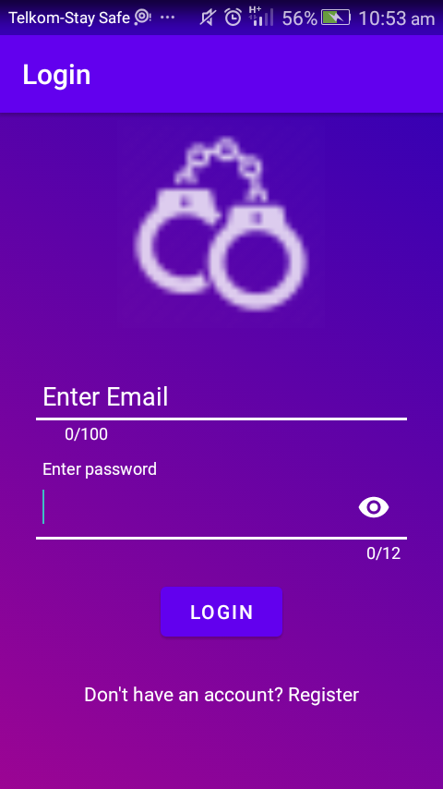

The above image represents the login page of the user. If the user does not have an account, he/she should have to register first.

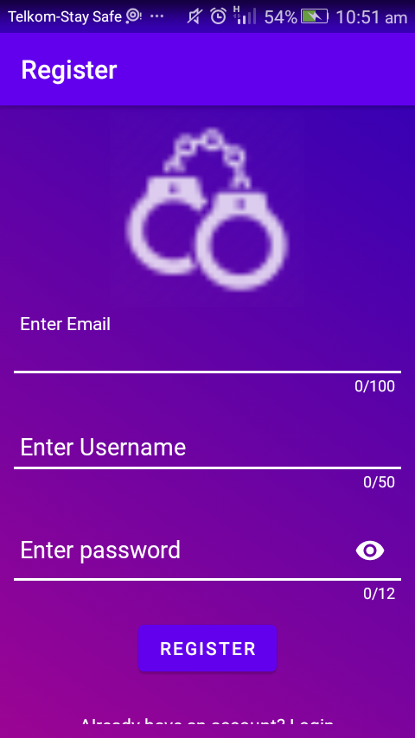

During registration the user needs to have an email, for successful registration. The username should also be unique.

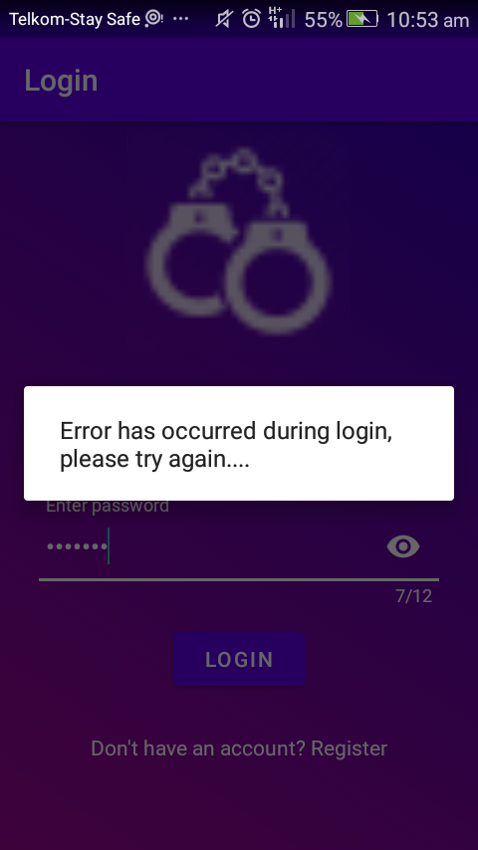

Wrong password prompts an error which will also prompt the user to use the correct password.

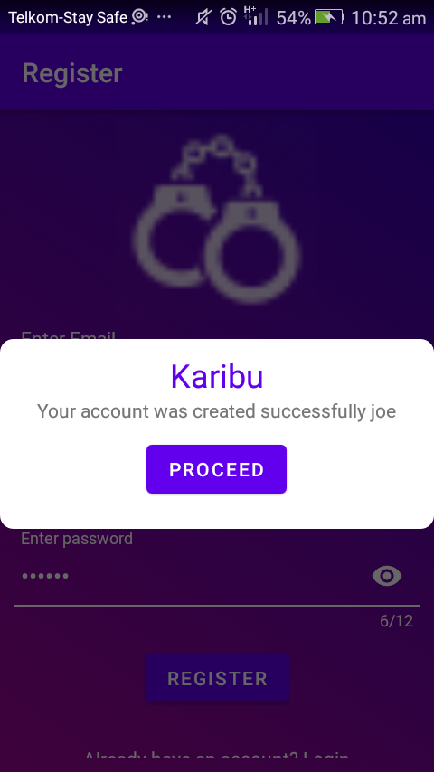

After successful registration the user will be prompted to proceed to the next interface where he/she will be reporting the crime.

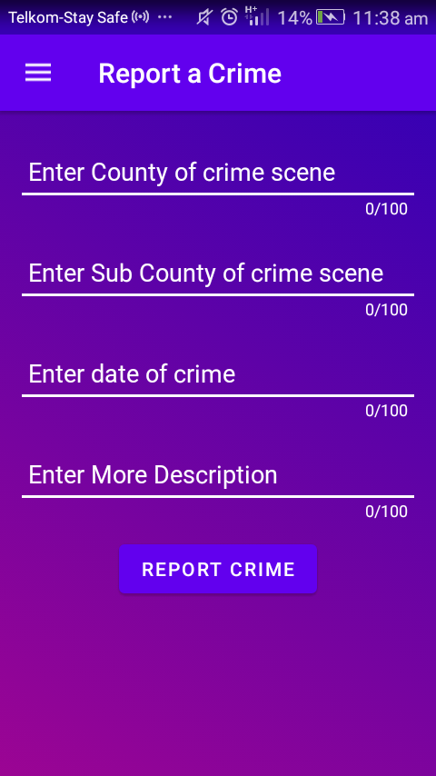

The user of the system is prompted to this page where he/she will report the crime.

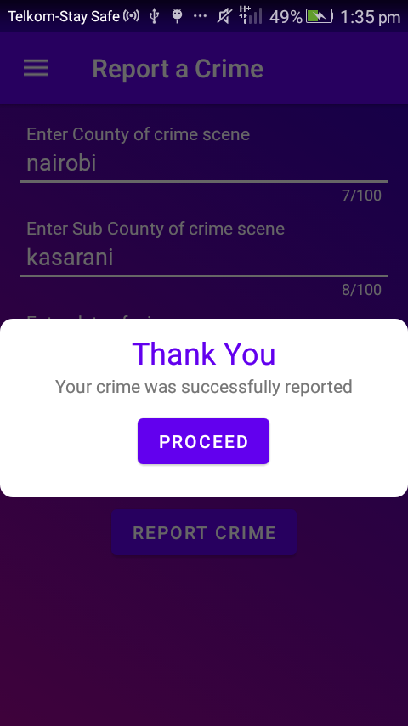

This is the screenshot after reporting your crime. This will be stored in the database where both the admin and the developer will be able to access the information on the crime after reporting successfully.

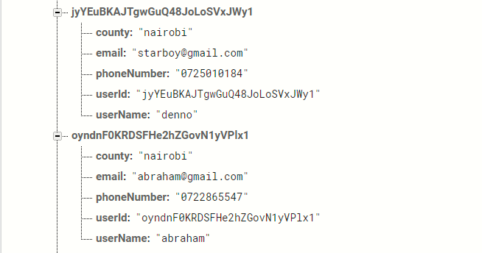

These are some of the persons who reported crimes with their usernames and numbers. The numbers in the database are the ones which will be used by the admin to call the respective person who reported the crime. The admin will login using the firebase login given by the developer. The developer will have the power to change the password in case the admin of the police will delete some of the data from the database.

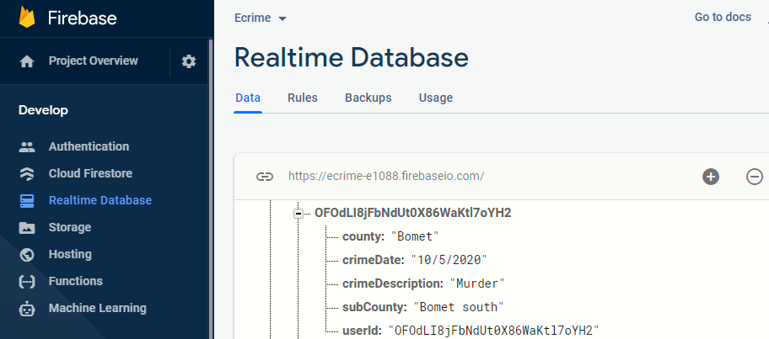

This is the interface of the database in which the admin will be viewing. The data can be added or deleted as seen in the figure above.

# CHAPTER 6: IMPLEMENTATION OF THE SYSTEM

## 6.1 Introduction

System implementation intends to define how information system should be built, ensure that information system is operational and that it meets its objectives or standards. On the other hand, system testing which a level of software is testing where complete and integrated software is tested to evaluate the system’s compliance with the specified requirements is also covered in this chapter.

## 6.2 Coding

It is the process of turning program logic into specific instructions that can be executed by the computer system. The programs were constructed and modules for the system which are administrator module and civilian module were coded. The programming language used was Java for the civilian or reporter’s side that is android. PHP (Hypertext Preprocessor) was used to code the server side. JSON, XML and firebase database were also used.

### 6.2.1 Tools Used in System Implementation.

Json and XML

Database support: firebase database

Programming language: Java

Web browser: Mozilla Firefox and Google Chrome

IDE (Integrated development environment): Android Studio

## 6.3 Testing

Testing is done to evaluate the capability of software and to determine whether it produces the correct results. Software testing is done for the following purposes.

* + - 1. For reliability estimation
      2. To improve quality
      3. For verification and validation

A software is tested to check for correctness, reliability, usability, integrity, efficiency, flexibility, reusability, maintainability among others.

We used black box testing to test our system. The method was chosen because it focuses on all the system functionalities. In order to carry out this testing it is important to understand the relationships between different modules.

Under the black box testing we carried out the following:

1. **Unit testing**

Testing of individual components independently.

1. **Module and Integrated Testing**

Components form modules which are integrated to sub systems for testing. Testing is a collection of modules and sub systems to discover any interface mismatches. It ensures that each module performs as expected in isolation. The administrator module and civilian module were tested with test data to confirm that they performed according to the user requirements specification.

1. **System Testing**

This involved testing the system as a whole, to confirm whether all the modules in the system were working in collaboration with one another. All the two modules which are administrator module and the civilian module were integrated and tested as a whole system to ensure that there are no conflicts in the system functionality.

1. **User testing.**

The user is given the system and documentation. The user is not a programmer and therefore he/she doesn’t check for any programming errors. We find out what the user says about the system. This was done using one civilian whom we met and doesn’t have much education. The civilian found the system easy to use and helpful in reporting crime.

## 6.4 Module Design

The system consists of two modules,

1. User module
2. Administrator module

**User module**

User interface consist of a login and register option. The user can register and be directly directed at the crime reporting section as a new user or an already registered user can login and report a crime.

**Administrator Module.**

Administrator interface consist of a login name and unique password using which admin can log into the database of the application. Administrator has the main control of the system.

# Chapter 7: LIMITATIONS, CONCLUSIONS AND RECOMMENDATIONS.

## 7.1 Limitations of the System

1. Not everybody has access to smartphones in Kenya which would help them report crime if any.
2. The amount of mobile data needed to access the application is not much, but the mobile service providers provide expensive amount of data which not everybody can be able to buy.
3. This application might not work on some android versions.
4. The security system of Kenya is corrupt and some police might be assigned duties in which they cannot report to the scenes where they are allocated.
5. We cannot miss people who give out the wrong information and police might be sent out there just for no good reason or even get there is nothing to be resolved.

## 7.2 Conclusion.

The aim of this research was to come up with a crime reporting application which as explained in the literature review the amount of cases are rising day in day out in our respective neighborhoods which is a critical matter at hand. It was also to help the people to understand that they do not have to go report a crime to the police manually but they can do it with a smartphone in their hands, and also trust the police will come and solve any issues the civilians have.

The system is android based and the users are required to have android-based devices in order to use the system. They should also have internet access. The application will enable the civilians to report any crime they get to see.

## 7.3 Recommendations

1. Data collected in a very long time should be able to help the officers or the head of the officers to deploy more policemen in areas where there are many complains of for example areas where burglary and other petty crimes are witnessed.

# References

1. Abrahamsen, R., & Williams, M. (2005). The Politics of Private Security in Kenya*. Review of African Political Economy,* 32(104/105), 425-431. ACPO (Association of Chief Police Officers) (2002) Investigation of Volume Crime Manual. London:
2. ACPO Abrahamsen, R., & Williams, M. (2008). Editorial: Public/Private, Global/Local*: The Changing Contours of Africa's Security Governance. Review of African Political Economy,* 35(118), 539-553.
3. Arnot, C., Luckert, M., & Boxall, P. (2011). What Is Tenure Security? Conceptual Implications for Empirical Analysis. *Land Economics*, 87(2), 297-311.
4. Ali, S., Briand, L. C., Hemmati, H., & Panesar-Walawege, R. K. (2010). A systematic review of the application and empirical investigation of search-based test case generation. *IEEE Transactions on Software Engineering*, 36(6), 742-762.
5. Al-Mudimigh, A., Zairi, M., & Al-Mashari, M. (2001). ERP software implementation: an integrative framework. *European Journal of Information Systems*, 10(4), 216-226.
6. August, T., & Tunca, T. (2006). Network Software Security and User Incentives. *Management Science*,52(11), 1703-1720.
7. Choo, K. K. R., Smith, R. G., McCusker, R., & Australian Institute of Criminology. (2007). *Future directions in technology-enabled crime: 2007-09*. Canberra: Australian Institute of Criminology
8. Harris, M., Collins, R., & Hevner, A. (2009). Control of Flexible Software Development Under Uncertainty. *Information Systems Research,* 20(3), 400-419
9. Gimode, E. A. (2001). An anatomy of violent crime and insecurity in Kenya: the case of Nairobi, 1985-1999. *Africa Development/Afrique et Développement,* 26(1/2), 295-335.
10. Mutahi, P. (2011). Between illegality and legality :(In) security, crime and gangs in Nairobi informal settlements. *South African Crime Quarterly*, 37, 11-18.
11. Ruteere, M., & Pommerolle, M. E. (2003). Democratizing security or decentralizing repression. The ambiguities of community policing in Kenya. *African Affairs*, 102(409), 587-604.
12. Van Dijk, J. (2007). *The world of crime: Breaking the silence on problems of security, justice and development across the world*. Sage.
13. [www.cid.go.ke](http://www.cid.go.ke)
14. Newiss, G. (2002) Responding to and investigating street robbery. (Unpublished).
15. Nieh, J., & Lam, M. S. (1997). *The design, implementation and evaluation of* SMART*: A scheduler for multimedia applications* (Vol. 31, No. 5, pp. 184-197). ACM.
16. Otwin, M. and Michael, R. (1995).; Journal of Criminal Justice, Vol. 23, No. 6, pp. 501-518, 1995

# Appendix

## Sample of project codes.

Login.

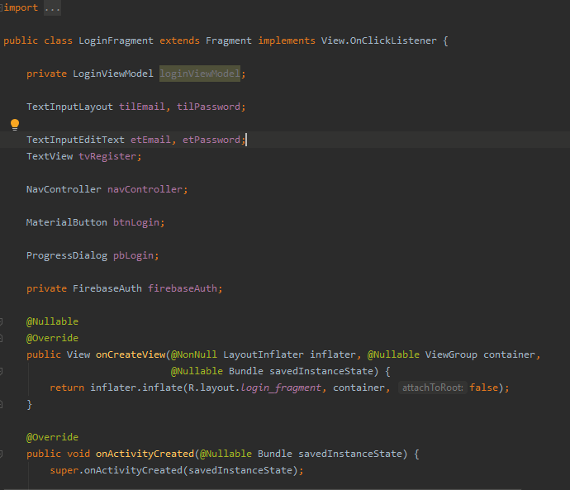

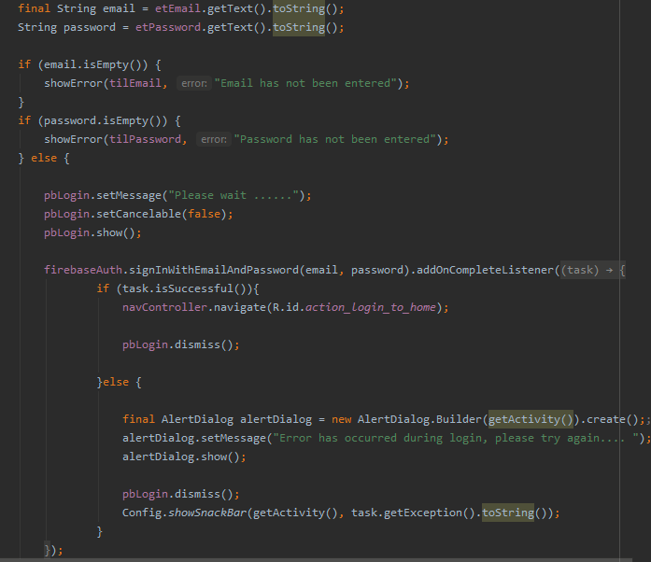

Registration.

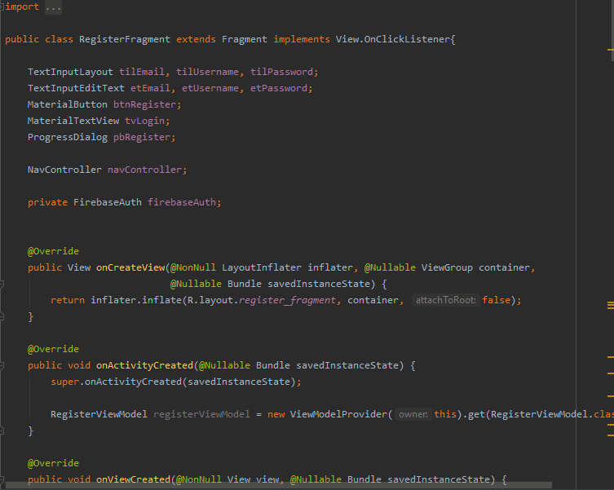

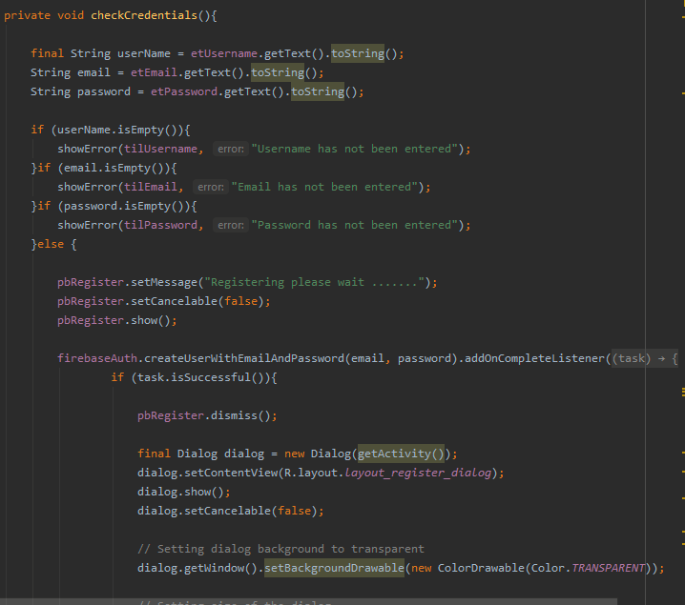

Report Crime Fragment.

